Objective:
Understanding the basics of parallel input and output using a PIC18F4620 to control both regular LEDs and RGB LEDs with DIP switches.

Summary:
We used registers TRISA, TRISB and ADCON1 in part one. We used the ADCON1 register to set the PORTA and PORTB registers as digital input and output. TRISA was used to set PORTA as an input and TRISB was used to set PORTB as an output. We programmed the PIC18F4620 to take the switch values as inputs then mask the unused bits by using a bitwise AND operation then setting PORTB equal to the outcome. PORTB was connected to three LEDs that would turn on when its corresponding switch was open and turn off when the switch was closed.

In part two, we used the same input system as in part one but changed the output to PORTC. We also changed the output LEDs with one RGB LED. We connected the least significant input bit to the red pin, the most significant input switch to the blue pin and the middle input switch to green. This allowed us to control the color of the RGB LED.

In part three, we programmed the PIC18F4620 with a for loop and a delay to control the color of the RGB LED. The for loop would count up from values zero to seven and delay for one second at each value. The values would be the input for the RGB LED value with the least significant bit being assigned to red, the most significant bit being assigned to blue and the middle bit being assigned to green.

In part four, we added an additional RGB LED and programmed the PIC18F4620 with two arrays that control the order of colors. The two RGB LEDs would flash at the same rate but with a different color order. We set both output PORTs to the value of its corresponding array inside a for loop with an incrementing index for both arrays.

In part five, we connected the output pins to a logic analyzer to get a visual waveform of the output logic levels. The channels were ordered in descending order starting with the most significant bit. This waveform allows us to see which color was being displayed for both RGB LEDs. Our annotated wave form is included in the Data Collected section.

Data Collected:
Annotated Logic Analyzer Waveform
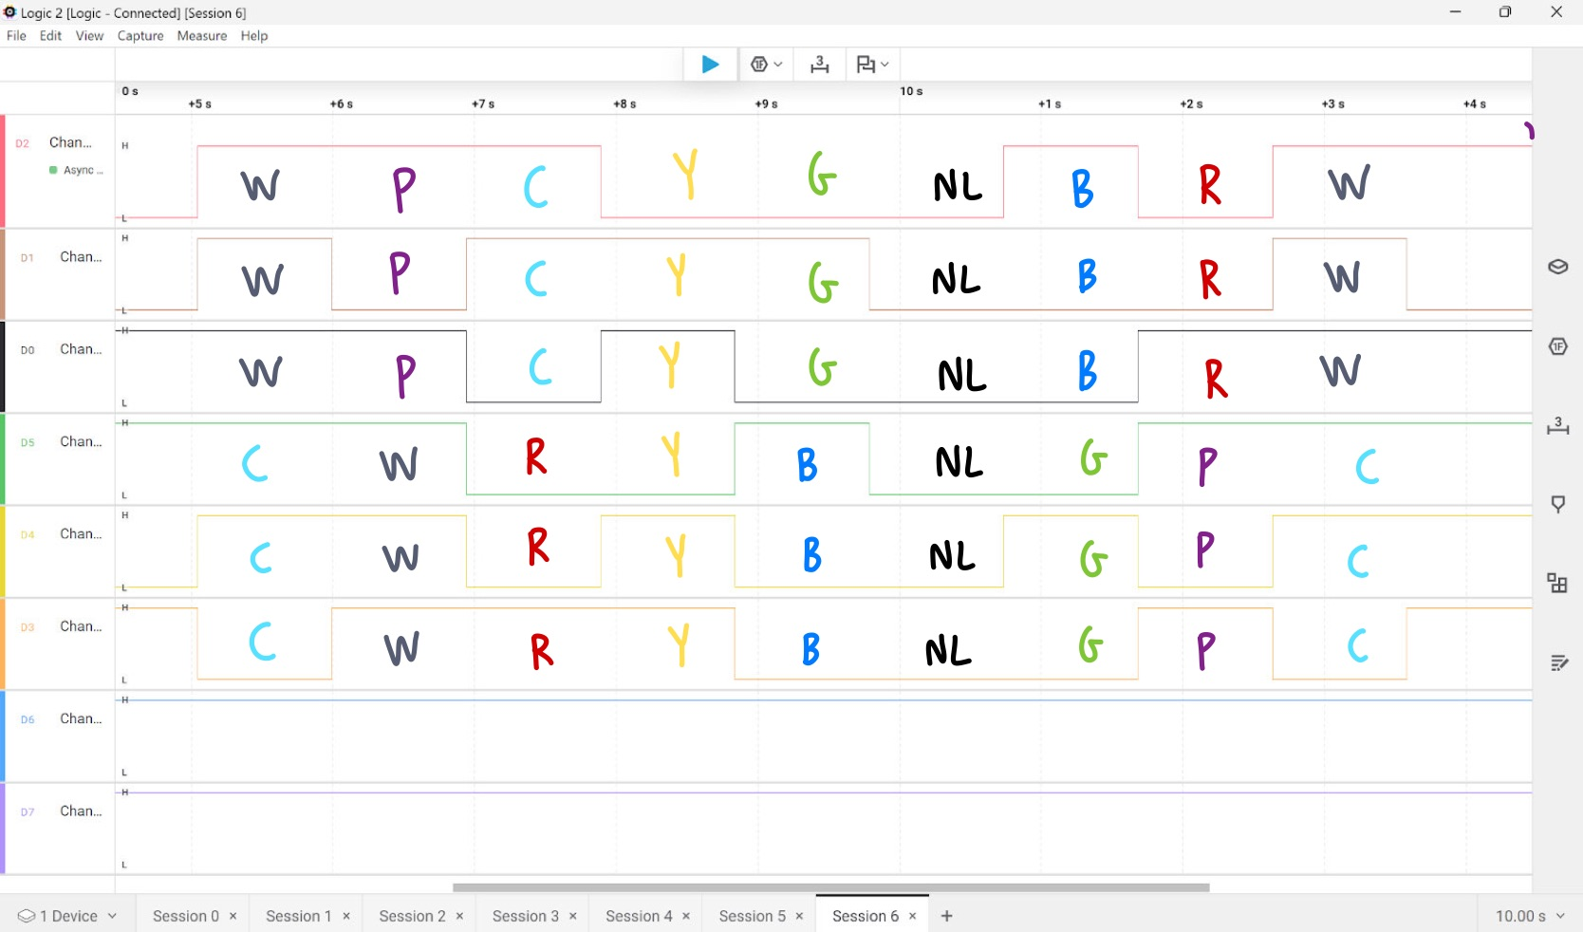

Conclusion:
The parallel digital input and output of the PIC18F4620 was very effective in processing inputs and displaying outputs. Knowledge of registers such as the ADCON1, PORTx and TRISx are very important for the completion of this experiment. We learned that each bit of the ADCON1 register controlled a different setting in the PIC18F4620. The pin connections are another important part of this lab. Failure to use the PORT connectors on the PCB would have ruined the LEDs because it would bypass the current limiting resistors built into the PCB. This experiment gave us a better understanding of registers and parallel digital input and output.

